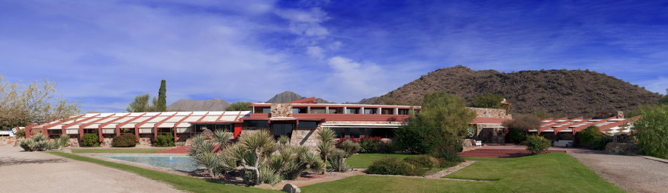
Events@FrankLloydWright.org – 12621 N. Frank Lloyd Wright Blvd., Scottsdale, AZ 85259

Event Facility Rental Rules & Procedure

In 1937, architect Frank Lloyd Wright began the design for Taliesin West in the desert foothills of the McDowell Mountains. Taliesin, meaning “shining brow,” was designed to house Wright’s winter home, studio, and architectural laboratory, which resided at the property from November to April of each year (and continues today as the School of Architecture at Taliesin). Each detail of the complex was designed by Wright and his apprentices to be in harmony with the surrounding environment. Wright used timber beam construction, stone sourced from the site, and a concrete mix incorporating sands from the nearby washes to construct the buildings. The whole complex seems to be one with the landscape. Using overlapping grids to lay out the site, the buildings, outdoor rooms, and landscaped terraces were designed to frame Wright’s favorite views of the desert. Boulders, some with Hohokam petroglyphs, were placed at strategic points within the landscape as a reminder of the site’s Native American history. Taliesin West was designated a National Historic Landmark in 1982.

Events Permitted
- Corporate private events
- Preforming Arts events private or open to the public
- Fundraisers not conflicting with Foundation’s mission

Events Not Permitted
- Political
- Religious
- Social events such as wedding receptions, bridal showers, birthday parties, rehearsal dinners, baby showers, bar/bat mitzvahs, family reunions, anniversary parties, retirement parties, celebrations of life or memorial services.

Foundation does not allow any activity or event which may result in damage or disturbance to Taliesin West’s staff, property, residents, the school or public use of the property.

Site Tours
Taliesin West invites you to an exclusive tour of the event spaces during regular business hours. Our Event Staff will escort you through the property, share tidbits about each space so you may see all the Frank Lloyd Wright has to offer your group. Site tours must be scheduled at least 48 hours in advance with Event Staff.

Book Your Event
Dates fill up quickly. A complimentary 14-day hold may be placed on any available date and event space. After the 14-day hold, your date and venue is not guaranteed without a signed contract and deposit.

Exclusivity
The event space you rent is private to your group, while simultaneous events or public tours may occur at Taliesin West. To provide your group with exclusivity to all of Taliesin West event spaces, a buy-out of the property is required.

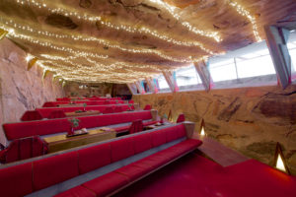
Cabaret: The Cabaret Theater is where Wright’s love of Asian art is most elaborately illustrated, with a large Chinese dragon motif emblazoned on the double doors and the central display of a Ming Dynasty cast-iron Buddha head. The cabaret allows your guests to make use of original Wright-designed chairs, seats, and tables, while the unique shape and construction of the space create optimal acoustics so that someone sitting in the back row can hear a faint whisper from the stage. (Indoor space seated 50/standing 60)
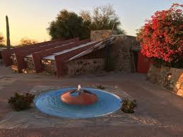
Cabaret Terrace: Your guests will savor their time on the Cabaret Terrace surrounded by Wright’s famous organic architecture. The panoramic views overlooking the Sonoran Desert and the lights of Scottsdale create the perfect intimate setting for your event. (Outdoor space seated 110 /standing 125; limited availability)
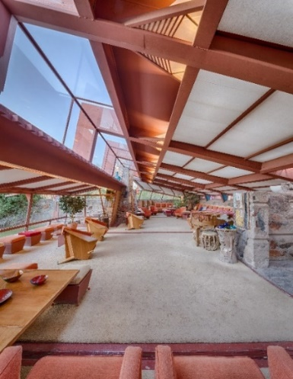

Garden Living Room: The Garden Room was and remains the showpiece of Taliesin West, with its dramatic canted roof. It’s the space where Wright, his family, guests, and apprentices would casually socialize every weekend. Designed and remodeled continually by Wright, it evolved from an open patio facing the original vegetable garden into a spacious enclosed room furnished entirely with Wright-designed furniture and original accessories. This is the perfect space for discerning guests desiring a uniquely Wright experience. (Indoor seated 25; standing 40)
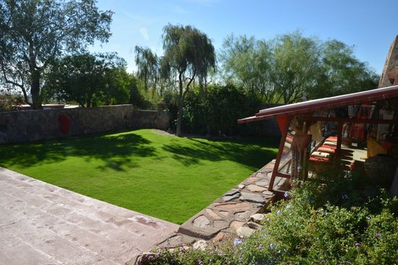
Garden Room Lawn: Facing the Garden Room, and originally the vegetable garden that provided fresh produce for the community, this Japanese-inspired garden now comprises a beautiful lawn flanked by historic Wright-designed Sprites from Midway Gardens. (Outdoor seated 70/standing 90)

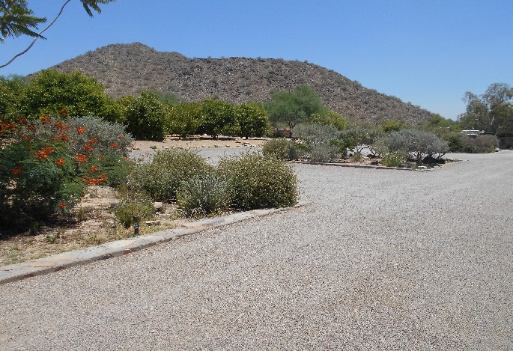
Garden Squares: ‘Aiming for the Mark’, a bronze sculpture of an archer created by Wright’s apprentice Heloise Crista, welcomes you to the Garden Squares. This vast event space at the heart of Taliesin West is surrounded by the Pavilion, Wright’s office, and the Drafting Studio, so that your guests are immersed in all things Frank Lloyd Wright. This space is large enough for any event you can dream up. (Outdoor seated 400/standing 550)

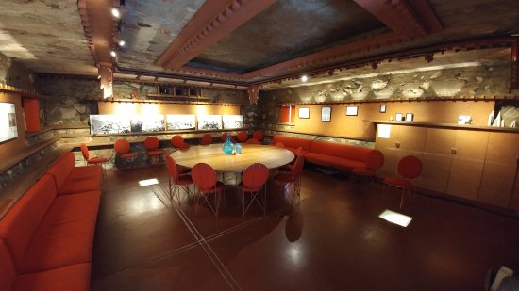
Kiva: The Kiva, which gets its name from an underground chamber used by Pueblo Indians for religious rites, was one of the first structures built on the property. It has served as a dining room, movie viewing room, lounge, and library. This hidden treasure has five different lighting techniques designed by Wright which create an inviting ambiance for any select event. (Indoor, seated 15/standing 20)

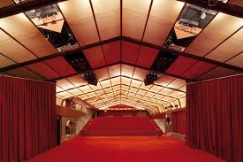
Music Pavilion: Opened in 1957, this is the last structure Wright added to Taliesin West. A symphony of red seats, curtains, and carpeting celebrates what Wright believed to be one of the life-giving colors of creation. The Pavilion continues to function as a multi-purpose hall for exhibitions, concerts, parties, and public meetings. (Indoor seated dinner 120-150/standing 200/theatre 126)

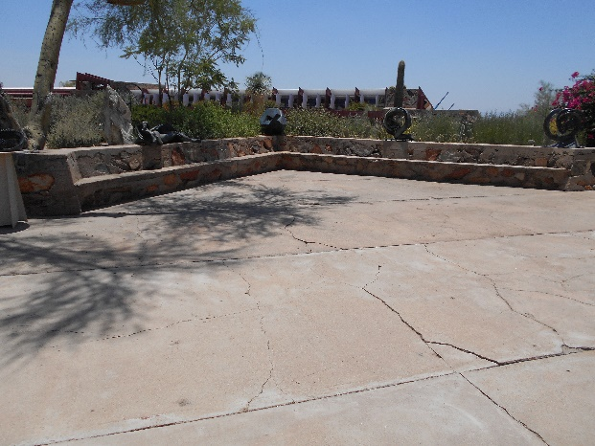
Pavilion Terrace: Situated just outside the Music Pavilion, the Pavilion Terrace features Wright’s former apprentice Heloise Crista’s many sculpture masterpieces. Take in breathtaking views of the Valley from this serene space. (Outdoor seated 50/standing 65)

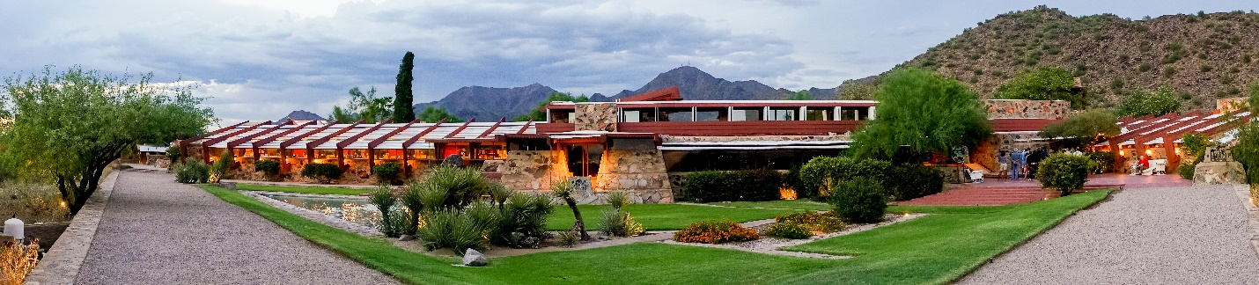Prow & Sunken Garden/ Sunset Terrace: The Sunset Terrace is a triangular terrace that steps down gradually to the Prow. On the east, the terrace faces the garden room (1940), the Wright family’s living quarters. At the front of Wright’s desert laboratory masterpiece is the Prow, a triangular garden and lawn with geometric beds filled with native plants that extends out to the view that Wright called “standing on the rim of the world.” There is no better view in the Valley than the Prow at sunset, while the main buildings Taliesin West and the backdrop of the McDowell Mountains softly change color as day flows into evening. The Prow is a full 360 degrees of splendor and awe. (Outdoor seated 380/standing 420)

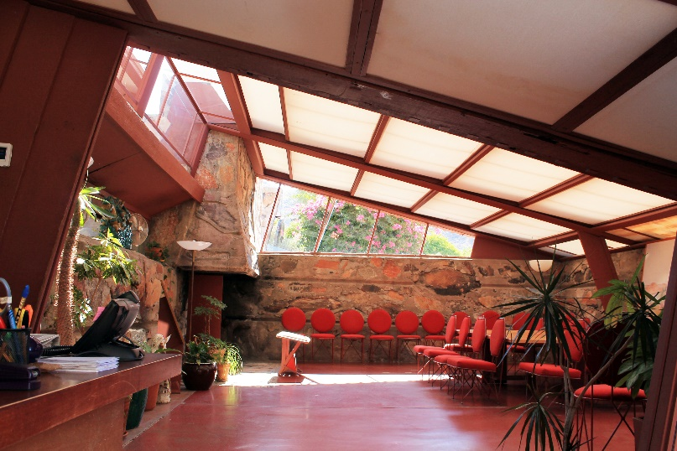
Wright’s Office: The building that served as Wright’s business office and reception area, and part-time design studio served as the impressive presentation space for Wright’s prestigious clients. It was here that he would welcome guests and present his newest ideas, drawings and models. Originally presented as a tented desert camp space, with a canvas roof and flaps instead of doors and windows, this space continues Wright’s design tradition of a fireplace in every room and an outdoor patio. (Indoor seated 10/standing 20)

Event Planning
Our Event Staff will work on behalf of Taliesin West to coordinate your event on property. This means we will work with you to tour the spaces, we will create a custom proposal for your event, contract, collect fees and certificates of insurance (COI), coordinate timing with your vendors and have necessary event staff on site for your event.

You will contract with our Approved Vendors to create your menu, rent your tables and chairs as well as contract any other services your event requires.

Pricing
Once we have all your event specifics, Foundation Event Staff will customize an event proposal with pricing specific to your group and event(s).

Payment Information
A deposit of one half (1/2) of the rental fee with the Foundation is due with submission of signed contract. The remaining one half (1/2) of the rental fee plus any fees for event amenities are due 30 days prior to the Event. You may pay via Credit Card Authorization or check. All checks should be made payable to the Frank Lloyd Wright Foundation. Event space is not guaranteed until signed contract and deposit are received.

Use of Space
The Property consists of a large complex of buildings and land, which includes business offices, public tour spaces, a school, and private residences. Access for your attendees is only permitted to your contracted event space.

By contracting event space, you and your guests agree not to interfere with the activities of the Foundation, school, residents, or other guests and will be courteous and use common sense while conducting event on Property.

All activities or events at Taliesin West must be consistent with the purposes of Frank Lloyd Wright Foundation and Taliesin West as well as appropriate for the facilities. All activities and entertainment must be approved in advance by Foundation Event Staff.

Behavior or activities that are offensive, abusive, illegal or which may result in the endangerment of Foundation guests, staff, residents, visitors, or property are expressly prohibited. Foundation staff will request that individuals engaging in such behavior leave the property.

Included in the rental fee:
- Usage of the contracted Event Space for the contracted date and time
- Additional hours as outlined in the contract for set-up and tear-down of the event
- Onsite venue coordination
- Directional Docents or signage from entrance to your Event Space
- Complimentary auto or shuttle parking for your group (space permitting)

Event Amenities
Self-guided tours: Your guests will enjoy exploring Taliesin West at their leisure. Docents
will be in 3-5 preselected spaces around your Event space to delight your
guests with information about each space, stories of Frank Lloyd Wright and fun
facts of Taliesin West. Preselected spaces dependent on location of reception.

Docent Led Tours: Each tour is a feast for the eye; the knowledgeable docents understand what Wright was trying to achieve architecturally, and their explanations are enlightening as well as entertaining. Docents will lead your guests to 3-5 preselected spaces around your Reception space and treat them to an intimate tour.

Customized Tours: Frank Lloyd Wright Event Staff will customize a tour exclusively
for your event.

Fireplaces: Lighting of built-in Fireplaces (not all spaces permit this option; weather permitting)

Dragon: Lighting of fire Breathing Dragon (weather permitting)

Speakers:
- A Frank Lloyd Wright Expert Docent will speak to your group about all things Taliesin West.

- Head of Preservation, Fred Prozzillo, Guest Speaker to speak to your group about Frank
Lloyd Wright and Taliesin West

- FLW Foundation CEO, Stuart Graff, Guest Speaker to speak to your group about Frank
Lloyd Wright and Taliesin West

Guest Memento: Customize your guest’s Frank Lloyd Wright experience with a unique
memento. The Frank Lloyd Wright Store at Taliesin West will work with you to choose just the right item that is sure to delight your guests.

Additional customizable amenities available on request

Property Access
Access to the Property for client and vendors shall be coordinated with the Foundation’s Event Staff. Taliesin West is not open to the public for free roaming. All guests and vendors must be accompanied by an authorized person while on property.

Vendors Client must contract with an Approved Vendor for all services provided during Event. All costs of third party vendors including rental of all items (tables, chairs, linens, serving items) and Catering costs are the responsibility of the Client. All third-party vendors or Caterers load-in/setup and strike schedule must be coordinated with Event Staff.

Approved Vendors

Caterers

Amici Catering – Lori Harlig – 602.866.1604
With over 60 years combined experience, Amici Catering is dedicated to developing lasting relationships though a shared love and passion for great food. Staying current on industry trends, Amici prides itself on creating delicious food, unique and innovative presentations and fabulous services.

Arizona Taste Catering – Candace Voorhees – 480.947.8844
Since 1966 Arizona Taste Catering has featured comprehensive turnkey event planning. A team of seasoned professionals guide you through all event components and guarantee a flawless event. Offering customized and flexible menu options for your special event.

Atlasta Catering – Alice Palmer – 602.242.8185
Established in 1981, Atlasta is the most diverse catering company in Arizona. Consistently ranked in the top two catering firms by The Phoenix Business Journal and featured in the Phoenix New Times, The Arizona Republic and Arizona Foothills among other publications, Atlasta's commitment to innovative menus, unsurpassed presentation and over-the-top service ensures a fabulous event. Atlasta also provides bartending services.

M Culinary - Deirdre Furlow – 602.200.5757
M Catering by Michael's provides singular dining experiences as Arizona's most trusted culinary culture. From receptions on the Prow to dinners in the Garden Square, M Catering exceeds expectations with seasonally inspired cuisine, locally sourced ingredients, thoughtfully crafted beverages and indulgently personal services. M Culinary also provides bartending services.

Santa Barbara – Melissan Falcone – 480.921.3135
Let Santa Barbara create a one-of-a-kind experience for you. Santa Barbara's delicious food and attentive staff will make you shine. With premium ingredients and made-from-scratch cuisine featuring local and seasonal ingredients prepared fresh on site, your meal will be one to remember. Check with Santa Barbara about their bartending services.

Sierra Bonita Catering – Kim Hopper – 602.573.2367
Sierra Bonita is a Phoenix based, full-service catering company serving the state of Arizona since 2010. Specializing in deliciously hand-crafted cuisine, they are committed to using seasonal and local products whenever possible. "Where exceptional cuisine, creativity, and sophisticated service come together to bring you a one-of-a-kind experience; your experience". Check with Sierra Bonita about their bartending services.

Bartending Service

Hey Bartender – 602.410.2227
Pour Masters – 602.505.7293

Hotel Partners

Hyatt Regency at Gainey Ranch - $5,000 F&B minimum
Frank Lloyd Wright Foundation has teamed up with the Hyatt to provide you with an amazing offsite event experience with the benefit of utilizing your group's food & beverage obligations to the hotel. Contact your hotel event services coordinator to schedule their offsite catering at Taliesin West.

AV Services

Erik Schmitz – 602.330.8620
Sound Lighting FX – Richard Lewis – 602.722.0783

Equipment/Event Rentals

Classic Party Rentals - Nicole Bunjovac – 602.763.7354
Event Rents – Roger Mexin - 602.516.1000

Florist

Butterfly Petals – 480.882.2436
Table Tops Etc. – 602.252.2966
Your Event Florist – 480.203.2740

Valet Services

American Valet – Mia Hillery 602.861.9182

Liquor Policy
Taliesin West and the Foundation do not hold a liquor license. For private events where a liquor license is not required by law, liquor, beer, and/or wine must be distributed by an Approved Vendor; cash bar is not permitted. For events open to the public a Special Event Liquor License is required.

Equipment/Technical Support
Foundation does not provide any equipment including but not limited to tables, chairs, AV equipment or support. Client is responsible for securing these items through an Approved Vendor. Some spaces have built in furniture that cannot be moved. Client is able to use these items in the contracted Event Space.

Electrical
If event requires more electricity than Taliesin West can supply, Vendor must contract with Approved Vendor for generator services.

Entertainment
Musical amplification systems are not permitted. Any non-music entertainment must be approved by event staff.

Decoration of Space
No decorations may be affixed to any element of the Property. All decorations that are used must be family friendly and safe for the Property, Staff, and Event participants. No open flame decorations are permitted.

Smoking
Smoking is never permitted, anywhere on the Property, at any time. No smoking is permitted inside any building or in any outdoor areas. Due to the dry desert environment and risk of fire from smoking materials, this policy will be strictly enforced.

Tent
Taliesin West does not allow tenting, except in the case of rain. Staking is not permitted. All tents must be contracted through an Approved Vendor only.

Rain
If a rain backup is not secured at time of contracting and we have an alternate indoor space available, we can offer to re-locate Event, but this cannot be guaranteed. There are no refunds due to weather.

Drones

Absolutely no drones are permitted for use on Foundation property.

Staking

Absolutely no staking on Foundation property. This includes but is not limited to signs, tents, etc.

Photography/Videography/Audio Recording
Any photography, videography and/or audio recording taken anywhere at Taliesin West may only be used for personal, non-commercial, or editorial purposes. Neither the Foundation’s publicity rights, nor

photographs or videography taken at Taliesin West, may be used in any company advertisements, product brochures or any other promotional materials without the express written consent of the Foundation. For Performing Arts events any photography and/or videography taken anywhere at Taliesin West to be used for commercial or profitable purposes requires a licensing agreement and must be contracted between Foundation’s Licensing Department and Client.

Ticketing

Foundation will not conduct event ticket sales on behalf of Client. All event ticket sales are the responsibility of Client.

Merchandise Sales
Client may offer CDs, shirts, hats and other approved items for sale at event and retain all proceeds from such sales. Client will be responsible facilitation and management of all merchandise sales prior to and at the performance.

Publicity
For any events open to the public, Foundation will include information of CLIENT event in the Taliesin West Events listing on the Foundation website. Foundation will also promote through Foundation social media and other available communications resources such as Foundation email list. Any distribution of media releases or paid advertising is sole responsibility of CLIENT. CLIENT must refer to the event location as specified below in all publicity. CLIENT may use “12621 N. Frank Lloyd Wright Boulevard, Scottsdale, AZ 85259” as the mailing address; however, CLIENT may also refer to the “GPS Address” as 12345 N. Taliesin Drive, Scottsdale, AZ 85258, if they wish. CLIENT will provide a contact phone number to direct public inquiries regarding the event. Any collaborative promotion between CLIENT and Foundation with traditional media (newspaper, radio), online resources (blogs, websites) or other resources will be agreed upon by both parties in writing before implementation. CLIENT agrees to stuff their program with flyer provided by Foundation.

Lighting

Foundation has limited theatrical lightning abilities for performing arts events.

Location Reference
All Events that take place at Taliesin West must refer to the specific space by its name:
Music Pavilion at Taliesin West
The Cabaret at Taliesin West
The Garden Room at Taliesin West
The Garden Room Lawn at Taliesin West
The Garden Squares at Taliesin West
The Prow at Taliesin West
Wright’s office at Taliesin West
For a venue buyout, refer to the location as Taliesin West

ADA Services
ADA restrooms are located at the Taliesin West Bookstore. The Bookstore is not open during all events. If Client or its guests need ADA-compliant restrooms they must contract with an Approved Vendor.

This National Historic Landmark consists of a large complex of buildings and land in a natural desert setting. It is a unique property and as such ADA guests may need additional assistance or services.

Cancellation Policy Cancellation of the Event must be provided to the Foundation’s Event Staff in writing. In the event of a cancellation more than 3 months prior to the Event, 50% of the deposit will be refunded. In the event of a cancellation less than 3 months prior to the Event, the deposit will not be refunded. A change of your event date (from one date to another) is considered a cancellation and all cancellation policies apply. The new date selected would be considered a new contract and full rental fees would apply.

Insurance Client shall provide Foundation with a certificate of insurance (COI) showing
- Commercial General Liability Insurance with a minimum combined single limit of $2,000,000,
- Liquor liability insurance with minimum limits of $2,000,000 per occurrence if applicable;
- Property/Business Interruption Insurance written on an All Risk or Special Perils form, covering Client’s personal property;
- Workers' Compensation Insurance as required by Law and including a waiver of subrogation in favor of the Licensor if applicable;
- Employers Liability Coverage of at least $1,000,000.00 per occurrence.

Any company writing any COI shall have an A.M. Best rating of not less than A VIII.

Description Box shall read: Frank Lloyd Wright Foundation, (or its successors and assignees), and their respective members, principals, beneficiaries, partners, officers, directors, employees, and agents and other designees of Foundation and its successors as the interest of such designees shall appear is/are as additional insured.

Certificate Holder Box shall read:
Frank Lloyd Wright Foundation
12621 N. Frank Lloyd Wright Blvd
Scottsdale, AZ 85259

